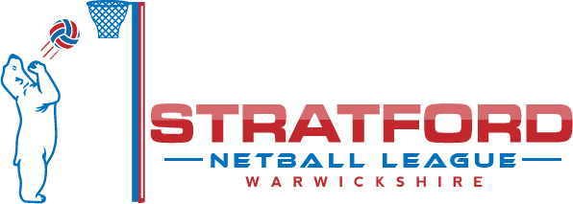

STRATFORD NETBALL LEAGUE UMPIRING 19/20

Only umpires who hold a current qualification are covered by the insurance offered by England Netball. *Please see below

- Umpires holding a Beginners Award are covered for 4 years from the date of the award
- Umpires holding an Into Officiating Award are covered for 4 years from the date of the award
- Umpires holding a C Award are covered, irrespective of the date of the award
- Umpires who have attended an Into Officiating course are covered for 24 months from the date of their course as they are classed as ‘in training’; the assumption being that they should gain their qualification within that time frame

Any umpires falling into the categories above will need to confirm the date of their award/course as appropriate in order to be eligible to umpire league matches.

Stratford Netball League will be working towards all umpires holding current qualifications. As with the previous two seasons, umpires who are not covered by England Netball insurance may still umpire league matches provided that:

- They have been league approved to do so by a member of the executive committee or someone appointed by them
- They have read and understood the risks involved in umpiring without the relevant insurance cover, and signed to this effect on the League Umpiring Disclaimer Form

* Details of the England Netball insurance cover is on the website for reference.

As stated at the start of last season, the expectation is that all teams entering the league for the 19/20 season shall register at least one umpire who is covered by England Netball insurance; therefore one with a current qualification or one who has attended a course and is working towards gaining their qualification.

If you have any questions in relation to the above, please don’t hesitate to contact Kate Halden.

STRATFORD NETBALL LEAGUE UMPIRING DISCLAIMER FORM

I have read and understood the above information regarding the insurance status relating to umpiring within the Stratford Netball League. I confirm that I wish to be eligible to umpire matches during the 19/20 season.

Name: ………………………………………………………………………….

Signed: …………………………………………………………………………

Date: …………………………………………………………………………….

This form is produced by the Stratford and District Netball League who as data controller will use the data collected in order to facilitate your participating in netball. You have a right to request a copy of the personal data that the Stratford and District Netball League holds about you at any time. If you wish to do so, please email khaldenuk@yahoo.com. For further information about what data we collect, why it is collected and what we do with it, please see our full privacy policy at www.stratfordnetball.co.uk

