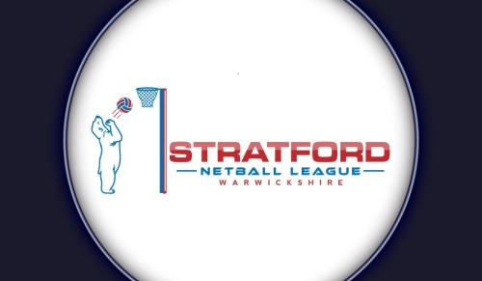

Stratford and District Netball League

Privacy Notice

The General Data Protection Regulation (EU) 2016/679 (the GDPR) will directly apply in EU Member States from 25th May 2018. The GDPR will govern how organisations use personal data and increase the protection of individual’s privacy. There will also be a new UK Act to replace the Data Protection Act 1998.

What this privacy notice covers

Stratford and District Netball League is committed to protecting your personal information. This notice explains how we collect and use the personal information about you. Personal data is processed in order to organise and promote the Stratford Netball League, communicate netball issues in Stratford and South Warwickshire, and support the development of umpires in the Stratford Netball League.

Stratford and District Netball League will be a “controller” of the personal information that you provide us during registration, unless otherwise stated.

What we need

When teams register to join the Stratford and District Netball League, we will ask you for the following personal information:
- Contact details – name, address, email address and phone number
- Confirmation that players have reached their 14th birthday within or before the playing season to confirm eligibility for the league
- Participation details – which club you are connected to (if applicable), and England Netball affiliation
If you do not provide us with all of the personal information that we need, this may affect our ability to offer you our services.

Why we need your personal information

We need to collect our members’ personal information so that we can manage your membership to the League. We will use our members’ personal information to:
- Send you membership communication by email in relation to essential membership services, including but not limited to, fixtures, general meeting notices, registration and information on fees.
- Promote and encourage participation in the sport of netball by sending communications and booking information for upcoming competitions and events.
- Develop and maintain our members’ membership status and umpiring qualifications, including sending email communications to members to inform you of relevant upcoming courses.
- Respond to and communicate with members regarding your questions, comments, support needs or complaints, concerns or allegations in relation to the sport of netball.

Please note that our fixtures and events may be filmed or photographed, and your personal information may also be used in images captured from our fixtures and events, which we may use for promotional, education and development purposes. If your personal information is included in any images or videos taken by us at our competitions, courses or events, we may share this on our website and social media

Other uses of your personal information

We may ask you if we can process your personal information for additional purposes. Where we do so, we will provide you with an additional privacy notice with information on how we will use your information for these additional purposes.

Who we share your personal information with

We may be required to share your personal information with statutory or regulatory authorities to comply with statutory obligations.
We may share your personal information with other members of the League for the purpose of coordinating teams and umpiring duties for League fixtures.

How we protect your personal information

Your personal information is stored in our League membership database. League volunteers protect their computers, tablets or phones so that files or data cannot be easily accessed. When League volunteers move to a new laptop, tablet or phone device, they are asked to securely wipe the device so that no data can be retrieved. Paper records are kept in a locked property, in a locked filing cabinet. This information is accessed by volunteers for the purposes set out above.

How long we keep your personal information

We will only keep your personal information for as long as necessary to provide you with League membership services. Unless you ask us not to, we will review and possibly delete your personal information where you have not renewed your membership with us for five years.

Your rights

You can exercise any of the following rights by writing to the League’s Executive Committee. Your rights in relation to your personal information are:

- You have the right to request access to the personal information that we hold about you by making a “subject access request”
- If you believe that any of your personal information is inaccurate or incomplete, you have a right to request that we correct or complete your personal information
- You have a right to request that we restrict the processing of your personal information for specific purposes
- If you wish us to delete your personal information, you may request that we do so.

Any requests received by the League will be considered under applicable data protection legislation. If you remain dissatisfied, you have a right to raise a complaint with the Information Commissioner’s Office at www.ico.org.uk.

